
PROLIFERATION OF SEXTING ON MENTAL HEALTH AMONG YOUNG ADULTS

AAMJ100 MAJOR PROJECT
Dissertation submitted in partial fulfilment of the requirements for the degree of BA (Applied Psychology)

Submitted By
Aaheli Adhikary
A91309620114
Batch: 2020-2023

Under the supervision of
Ms. Dipanjana Chatterjee
Assistant Professor

AMITY INSTITUTE OF PSYCHOLOGY AND ALLIED SCIENCES
AMITY UNIVERSITY, KOLKATA
TABLE OF CONTENTS:

SERIAL NO. | TITLE | PAGE NO.
1 | Certificate | 3
2 | Declaration | 4
3 | Acknowledgement | 5
4 | Abstract | 6
5 | Introduction | 6-8
6 | Objective | 8
7 | Procedure | 9
8 | Instrument | 9-10
9 | Result | 10
10 | Literature Review | 10-14
11 | Discussion | 14-15
12 | Limitations | 16
13 | Conclusion | 17
14 | References | 17-18
15 | Plagiarism | 19
16 | Appendix | 20

CERTIFICATE

This is to certify that this dissertation titled “Proliferation of sexting on mental health among young adults” is a bonafide work carried out by Aaheli Adhikary, A91306920114 of 2020-2023 batch at Amity Institute of Psychology and Allied Sciences, Amity University Kolkata, under my supervision and guidance.
This is to certify that, this work submitted by Aaheli Adhikary as dissertation in partial fulfillment of the requirements for the degree of B.A (Applied Psychology) has not formed the basis for the award of any degree or diploma to any candidate. This is a bonafide record of candidate’s personal effort.
Forwarded by:

DR. AKASH KUMAR MAHATO
ASSOCIATE PROFESSOR & HEAD
AIPSK, AMITY UNIVERSITY KOLKATA
Signature of Guide:

MS. DIPANJANA CHATERJEE
ASSISTANT PROFESSOR
AIPSK, AMITY UNIVERSITY KOLKATA

Date:

\

DECLARATION
I, Aaheli Adhikary, hereby declare that the study presented in this dissertation was conducted by me under the supervision of Dr. Dipanjana Chatterjee, Assistant Professor, Amity Institute of Psychology and Allied Sciences, Amity University Kolkata.
I also declare that no part of this study has either been previously published or submitted as a dissertation for any degree or diploma course in any university.

Signature:

Place: Kolkata
Date:

Acknowledgement

I would like to extend my sincere thanks to all of them who have extended their help for my work. I am highly indebted to my Professor Ms. Dipanjana Chatterjee for her guidance and constant supervision as well as for providing necessary information regarding the dissertation and also for her support in completing the dissertation. I would also like to express my heartfelt gratitude to her for giving me such attention and time.
I would also like to express my heartfelt gratitude towards our head of the institution - Dr. Akash Kumar Mahato, all my teachers at Amity university, Kolkata, my parents and friends of Amity university, Kolkata and outside for their co-operation and encouragement which helped me in completing this dissertation within the given time frame.

AAHELI ADHIKARY
(A91306920114)
B.A. (Honours). Applied Psychology,
Semester: 6, Batch: 2020-2023
Amity Institute of Psychology and Allied Sciences,
Amity University, Kolkata
Abstract: Sexting has garnered interest from the public and the scientific community given its ever-increasing presence among young adults' lives. Sexting is the exchange of sexual messages, photographs, or videos via technological devices and is common and increasing among youth. Although numerous studies have examined the association between sexting, sexual behaviors, and mental health, results are mixed. The practice of creating and sharing sexual images via technological devices, known as sexting, has received crescent attention in the past years, especially due to the increase of adolescent engagement in this behavior. Although consensual sexting is not prima facie a crime, as some research has shown, it has the potential to be a risky behavior, and a threshold to get exposure to dangerous kinds of victimization such as sextortion, online grooming, or cyberbullying. In this context, teenagers represent a vulnerable group due to their limited ability of self-regulation, their high susceptibility to peer pressure, their technophilic, and their growing sexual curiosity. The present paper aims to review the scientific literature to analyze the relationship between mental health and sexting as a potentially risky behavior and its association with online victimization. These calls for a standardized sexting instrument that addresses scientific evidence-based recommendations.
Keywords: adolescents, sexting, child victimization, mental health, threshold, questionnaire.
Introduction: The term sexting was first used in 2005 by the Daily Telegraph, to unify the terms “sex” and “texting” and became an official word in 2009. It is known as “Sending and receiving sexual content (e.g., photos, videos) via the Internet and mobile phones,” but there is no consensus around the definition of the term sexting in the scientific community. Therefore, it has been diversely defined, including from broad definitions that include the sending of any kind of sexual content to narrower definitions, which are image-based only. Some authors include coercion as part of the sexting behavior, while others consider that sexting is voluntary by definition; some definitions include sending text messages (non-image based) as part of the sexting behaviors, while others exclude them from the definition. The existing literature on sexting also differs in the population samples used for the research (teens vs. adults), and in the items used to measure sexting, which might be some of the reasons for the lack of a unified definition of the term.
The research on sexting has widely grown over the past few years, especially regarding adolescents and the negative effect it might have on their sexual development and mental health, specifically after the publication of the Sex and Tech Survey (2008) results, which was the first broad survey to examine this phenomenon. There is a conceptual debate in the scientific community that distinguishes between two clear arguing lines: one side tends to argue for a normalizing discourse whereby authors believe sexting to be a normative behavior as a part of sexual expression in a relationship, and it is possible to practice “safe sexting” to avoid negative consequences. The other side tends to argue that sexting is a risky behavior that requires intervention and prevention to diminish its prevalence and has been labeled as “deviance discourse.” Although sexting is a common behavior among the adolescent and young population, the deviance discourse has more scientific support than the normalizing discourse. For example, a recent meta-analysis published by Kosenko et al. found a significant relationship between sexting and three aspects of sexual behavior: general sexual activity, unprotected sex history, and number of sexual partners, that are all considered sexual risk behaviors. Similarly, a recent meta-analysis by Mori, Temple, Browne, and Madigan has indicated that sexting behaviors were significantly associated with sexual behaviors, such as sexual activity, having more than one sexual partner, and lack of contraception use. It was also found that sexting behaviors and internalizing problems, such as anxiety and depression, were significantly associatedKlettke et al. in their literature review found significant relationships between sexting and risky sexual behavior and with several other adverse outcomes, such as (a) the sharing of sexual content without consent, (b) legal consequences, and (c) negative mental health repercussions. Furthermore, research highlights an existing relationship between mental health or psychological health and online victimization behaviors, such as cyberbullying, online dating violence or revenge porn, which are closely related to sexting
Several studies have identified a relationship between cyberbullying and sexting behaviors. Fahy et al.’s investigation emphasizes the high prevalence of cyberbullying and the potential of cyber-victimization as a risk factor for future depressive symptoms, social anxiety symptoms, and below average well-being among adolescents. Their results show that cyber-victims and cyberbully-victims were significantly more likely to report symptoms of depression and social anxiety. According to these results, it would be expected that sexting behaviors as a form of victimization might also be related to a higher likelihood of reporting depressive and anxiety symptoms. Along the same line of reasoning, research findings indicate that a higher degree of depressive symptoms is associated with greater Internet use, and more frequent and problematic internet use is associated with higher rates of sexting behavior. Therefore, it would be reasonable to hypothesize that higher engagement in sexting behaviors might predict higher rates of depressive symptoms.
.
Objective: Considering the increasing number of suicides related to sexting, the relationship between sexting and mental health seems of interest, even though results are mixed. A few studies have investigated personality traits and their relationship with sexting; others have explored the relationship between sexting and sexual risky behaviors or substance abuse and emotional problems

Procedure: The administrations of the college were enacted by email in order to arrange meetings and explain the study’s goals and ethical procedure. Through the letter of consent, parents were also informed of the ethical procedure of the study, of the content of the questionnaire, and of their right to refuse the participation of their children, which occurred in only four cases. No agent required clarification or suggested modifying any of the questions. The data collection took place between 28th February, 2nd March and 5th March, 2023. The questionnaire was administered to the participating young adults in their usual classrooms, during regular class hours, and took approximately 40 minutes. They were informed that participation in this research project was entirely voluntary, and no negative consequences would result from them abandoning for not participating it in. Ultimately, no one abandoned or refused to participate in the major project. Participants were counted as 80 including the staffs, workers and students.
Instruments: The Sexting Behaviours and Motives Questionnaire (SBM-Q) was created for this research and is intended for the young adolescent’s population. It comprises 39 items measured by a category scale with five response options measuring behaviour frequency: 0 = never; 1 = less than once a month; 2 = monthly; 3 = weekly; and 4 = daily. Following the previously reviewed literature that highlighted the differentiation of the different behaviours, the forwarding victimization, and the motives for active sexting, six factors were designed. The first factor comprises six items that address sending behaviours, differentiating between the type of sexual content and the relationship of those involved. The second factor comprises nine items about reasons for sending. The third factor includes five items about being a victim of non-consensual forwarded content, considering the type of relationship the victim and perpetrator(s) hold. The fourth factor comprises six items and covers receiving sexual content, distinguishing between the type of sexual content and the relationship of those involved. The fifth factor comprises four items that address active forwarding (when you are the one doing the action) and passive forwarding (when you receive this forwarded sexual content about someone else). The sixth and final factor covers the reasons behind active forwarding of sexting was specified, understood as the sending, receiving or forwarding of sexually explicit or suggestive messages, images or videos through a technological device, analysing each sexting behaviour individually in order to evaluate the phenomenon in a comprehensive and precise manner.
A first version of the questionnaire with 33 items was edited, considering the different sexting behaviours and the type of relationship those involved had. This version was given for evaluation to 6 adolescents and 10 experts in the field of education and psychology. As a consequence, a second version was made with 39 items differentiating, moreover, according to the type of sexual content (Barrense-Dias et al., 2017). The questionnaire was again given to these same people and two more versions were made, changing wording and readability, until the final version was reached. Finally, the application and evaluation of the results were carried out.{American Educational Research Association (AERA), American Psychological Association (APA), & National Council on Measurement in Education (NCME) (2014)}.
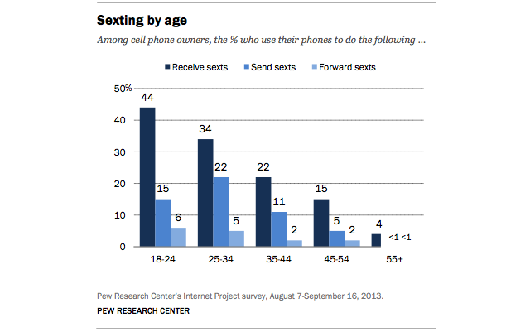
Results: The SBM-Q maintained the initial 6-component factorial design, covering different sexting definition and consideration items. The first factor (sending) has a reliability of α = 83. The second factor (reasons for sending) has a reliability of α = .89. The third factor (victim of forwarding) has a reliability of α = .75. The fourth factor (receiving) has a reliability of α = .84. The fifth factor (forwarding) has a reliability of α = .84. The sixth factor (reasons for forwarding) has reliability of α = .83. The total instrument has a reliability of α = .82. To calculate divergent validity, correlations between the SBM-Q and ECIPQ factors were compared. The results showed correlations that converge significantly with the dimensions, without any correlation being especially high. Lastly, the results from the multi-group analyses revealed significant differences between genders in the configuration and measurement invariance tests.
Literature Review: A study carried out by Ybarra & Mitchell evaluating psychosocial problems from a sample of 3715 teens aged 13 to 18 years old, found that psychosocial problems were more frequently observed in teens that had sent or showed sexual photos of them. In addition, they found that high self-esteem was negatively associated with having sent or showed sexual pictures, and for female teens, results showed a significant association between sexting and depressive symptomatology. Similarly, Ševčíková found that sexting was associated with emotional problems, and explored the possibility that this correlate might be both a predictor, as well as an outcome of sexting behaviors.
Regarding sexting and personality, the research carried out by Gámez-Guadix et al. shows an existing significant positive relationship between sexting and higher scores in Extraversion and Neuroticism and a negative relationship between sexting and Conscientiousness and Agreeableness. Brinkley et al. conducted a study with a sample of 181 adolescents to evaluate the relationship between sexting and Borderline Personality Disorder (BPD), amongst other variables. Their results supported the hypothesis that sexting at age 16 would be associated with borderline personality feature at age 18. In addition, the authors affirm that their findings suggest that sexting may contribute to psychological distress for adolescents.
Following these results, many investigations have linked sexting behaviors to impulsivity and substance abuse problems. Döring points out that sexting is related to impulsivity, bad judgment, sensation seeking, and problematic alcohol and drug use, as well as to suicide. This author considers sexting to be either a manifestation or moderator of problematic sexual behavior. On the other hand, Judge defines sexting as an emotionally-driven behavior, that is often related to impulsivity and a lack of anticipation of adverse consequences.
Englander, on the other hand, distinguished between pressured-sexters and non-pressured sexters, and her results show that pressured-sexters were more likely to report having problems during high school with excessive anxiety, although results were not statistically significant. Along the same line, Temple et al., did not find sexting to be a marker of mental health. In their study, they evaluated 937 teens from Texas public high schools on rating scales for depression, anxiety, impulsivity, and a positive response for a history of substance use. Their results show that subjects who had sent naked pictures of themselves to someone else through text or email were more likely to score higher on scales of depression and impulsivity, as well as more likely to report a history of substance use. However, when the results were adjusted for prior sexual behavior, age, gender, race/ethnicity, and parent education, sexting was only related to impulsivity and high-risk behaviors, but not to depressive symptoms.
Sexting and Depression
When considering research regarding sexting and depression, specifically, the vast majority of studies have found a positive association between depressive symptoms and sexting behaviors. Out of a total of 14 publications addressing this issue, 12 found a positive association between sexting behaviors and depressive symptoms.
One such example is a study by Dake, Price, Maziarz & Ward who conducted research based on 1289 middle school and high school students. Their results showed that being depressed, having contemplated or attempted suicide in the past year, or having been cyber or indirectly bullied were significantly correlated with sexting. Similarly, Van Ouytsel et al. found a significant relation between teen sexting and depressive symptoms. These results are in line with those found by Chaudhary et al., who conducted a study with 1760 teens and found that youth who reported sexting were significantly more likely to report symptomatology of depression and anxiety, as compared to those who did not report sexting. Specifically, their results showed that between 20% and 27% of youth who sexted had depressive symptoms. In addition, Bauman in a book chapter regarding sexting and cyber bullying and mental health consequences explains that young people involved in sexting had higher rates of suicidal thoughts than those who were not involved, and they also showed higher rates of high-risk behavior.
Finally, Gámez-Guadix and De Santisteban in a recent study carried out with 1208 Spanish adolescents between ages 12 and 16, found that a higher degree of depressive symptoms predicted a higher degree of sexting behaviors. At the same time, they found that teens who presented greater depressive symptoms were more likely to participate in sexting behaviors over time. Findings suggested a significant association between sexting behaviors and suicidal thoughts, suicide attempts, depressive symptoms, and feelings of sadness . Teenage boys and girls who engaged in sexting behaviors showed a higher risk of reporting suicidal thoughts even after controlling for cyber victimization and depression. One explanation for this relationship has been suggested by Medrano et al., who proposed that the relationship between sexting behaviors and depressive symptoms may be partially mediated by cyber-victimization. The exchange of intimate photos or videos increases the risk of being victimized, not only by the direct sender of the image-based sexual content but by anyone who might have access to it, as teens might find themselves involuntarily exposed to unwanted sexual content .
However, some research has found no association between mental health symptoms and sexting behavior. Morelli and colleagues conducted a study with 1334 teens and young adults between the ages of 13 and 30 years old, trying to assess the relationship between sexting, psychological distress, and online dating violence. Their results showed that a higher engagement in sexting was associated to a higher likelihood of offline and online dating violence. Moreover, their findings show no differences in psychological distress between people who sexted frequently and those who did not. Further, no relationship was found between sexting behaviors and symptoms of anxiety or depression. Finally, recent research conducted by Klettke and colleagues based on 598 young Australian and Indian adults did not find an association between the sending of sexts, depression, or anxiety. However, higher levels of stress were significantly associated with the sending of sexts. Regarding gender, for males overall, higher levels of stress and lower levels of depression were associated with sending sexts, while for females, there were no associations with mental health variables. In terms of cultural differences, higher levels of stress were associated with sending sexts for participants overall, and for Indian respondents, but not Australians when analyzed separately.
One explanation for why some studies have not found an association may be due to the level of consent. Frankel et al. collected data from a sample comprising 6021 US students between 9th and 12th grade to examine the relationship between consensual and non-consensual sexting and mental health. Their results show a correlation between consensual sexting and alcohol and tobacco use, being cyber-bullied and reporting both depressive symptoms and previous suicide attempts, especially in male respondents. Moreover, they found that non-consensual sexting was more prevalent among students who reported serious depressive symptoms, attempting suicide and self-harm.

Sexting and Anxiety Symptoms
Similar to the results observed regarding the analysis of the relationship between sexting behaviors and depression, the existing literature was reviewed to explore the relationship between sexting behaviors and symptoms of anxiety. Research exclusively investigating the relationship between these two variables is scarce; however, the majority of studies have found an existing relationship between the two variables. Out of a total of eight studies seven studies found a positive association between sexting behaviors and symptoms of anxiety.
For example, Chaudhary and colleagues found that youth who reported having engaged in sexting behaviors, based on 1760 teens, were significantly more likely to report symptomatology of anxiety. Their results show that between 57% and 61% of adolescents who sexted had symptoms of anxiety. Similarly, Cooper et al. reported that sexting victimization corresponded with negative psychological outcomes, including feelings of sadness, anger, and anxiety disorders. Finally, Klettke and colleagues collected data from a sample comprising 444 late teens and found that receiving unwanted sexts and sending sexts under coercion was associated with poor mental health; they found that, especially, when receiving or sending unwanted but consensual sexts, respondents reported higher levels of depression, anxiety, stress, and lower self-esteem.

Discussion: This investigation aimed to study the relationship between sexting, psychological distress, victimization, and perpetration of dating violence, exploring also gender and sexual orientation differences. The principal results suggested that individuals who are high and moderate users of sexting (vs. low) engaged in more victimization, and more perpetration of dating violence, including online dating violence. Moreover, high users of sexting (vs. moderate and low) showed more risky sexting behaviors (i.e., sexting during substance use, being forced to sext both by partner and friends, and sharing sexts with strangers). On the other hand, no differences regarding psychological distress were found between low and high users of sexting. To our knowledge, this is one of the first reports about sexting behaviors in the Italian context and results are consistent with previous international studies: The majority of participants reported receiving more than sending sexts (Dir, Coskunpinar, Steiner, & Cyders, 2013; Eurispes & Telefono Azzurro, 2011, 2012), a result that could be explained by social desirability. A low percentage reported posting sexts on social networks at least once (8.77%). Usually, previous studies about sexting assessed sending and posting in a composite measure and so, found a higher percentage of posting (The National Campaign & CosmoGirl.com, 2008). Our results showed a relevant percentage of participants (almost one third) reporting to have sexted during substance use at least once: This alarming result seems in line with studies that found sexting often related to substance use (Benotsch, Snipes, Martin, & Bull, 2013; Dake et al., 2012; Dir, Cyders et al., 2013) and could be explained with the disinhibitory effect of alcohol and drugs on sexual responsiveness (Justus, Finn, & Steinmetz, 2000; MacDonald, Zanna, & Fong, 1998; Wilson & Niaura, 1984). Moreover, a sizable proportion of participants that should not be overlooked (12.5%) reported to have sent sexts about someone else without his/her consents: This behavior, defi ned secondary sexting (Calvert, 2009), may sometimes hide harmful intentions and its consequences are often negative for the victims as enlightened in studies about the so called revenge porn (Calvert, 2013; Tungate, 2014). In line with our expectations, we found differences regarding gender and sexual orientation: Males (vs. females) and nonheterosexuals (vs. heterosexuals) are higher users of sexting. These results are also consistent with previous research studies and suggest that higher sexting behaviors among non-heterosexuals could be due to a more frequent use of social media communication: As recently found by Chong, Zhang, Mak, and Pang (2015), social media facilitate communication and relationships, and improve psychological and social-emotional well-being among lesbian, gay and bisexual people. Thus, social media could be a protective factor against stressors due to social stigma, prejudice and discrimination, as theorized in Minority Stress Model (Meyer, 2003). Regarding age, no differences were found between adolescents and young adults: Previous studies investigated sexting prevalence either among adolescents or among young adults (Dake et al., 2012; Gámez-Guadix et al., 2015; Lenhart, 2009; Strassberg et al., 2013; Temple et al., 2012) and found differences between younger and older adolescents and between young adults and older ones. Maybe this study could not fi nd differences between adolescents and young adults because the focus was on sexting frequencies: Probably some age differences could be enlightened in a deeper investigation regarding motivations and expectations related to sexting behaviors. This study suggests that a high use of sexting is more related to other problematic behaviors. Specifically, high users of sexting are more likely to sext during substance use, to be forced to sext by partners and by friends, and to send sexts to strangers. These results extend previous similar findings (Benotsch et al., 2013; Dake et al., 2012; Dir, Cyders et al., 2013; Temple et al., 2014) by pointing out the differences between low and high users of sexting. Our results also confirmed the relationship between sexting and dating violence (Gámez-Guadix et al., 2015; Tobin & Drouin, 2013). Specifically, moderate and high users of sexting are more likely to be perpetrators and victims of dating violence, including online, than low users of sexting. On the other hand, we did not find significant differences regarding psychological health among the three groups of sexting, as found in previous studies (Hudson, 2011; O’Sullivan, 2014; Temple et al., 2014). Results suggested that moderate and high use of sexting could be a risk factor for some problematic behaviors such as dating violence, even if there is no relationship with anxiety and depression symptoms. On the other hand, low use of sexting could be a weak index of the tendency to other problematic behaviors because it seems to be less related to dating violence: However, also low users should be deeply monitored across age by future longitudinal studies because previous studies showed an increasing of sexting behaviors due to the spread of new technologies in only two years (Eurispes & Telefono Azzurro, 2011; 2012). Therefore, our results suggested that sexting, practiced at a low level, could not be defined per se as a risk factor, supporting Levine’s hypothesis (2013). Future studies should be conducted to examine more deeply whether there are differences regarding motivations, expectations, and attributed meanings of sexting behaviors among different groups of sexting use.

Conclusion: The findings of this narrative review seem to point towards the presence of mental health symptomatology, particularly depression and anxiety, in the adolescent population when related to sexting behaviors. However, the age of the adolescents also seems to play an important role, as observed by Mori et al. As, adolescents get older, mental health symptoms seem to be increasingly associated with aggravated sexting, but not when related to consensual sexting behaviors whereby older teens have not been pressured (experimental sexting). Therefore, it might be probable that the relationship between sexting and poor mental health, depression, and anxiety symptoms is mediated by coercion, victimization, and age. Future research is needed to explore this hypothesis further.
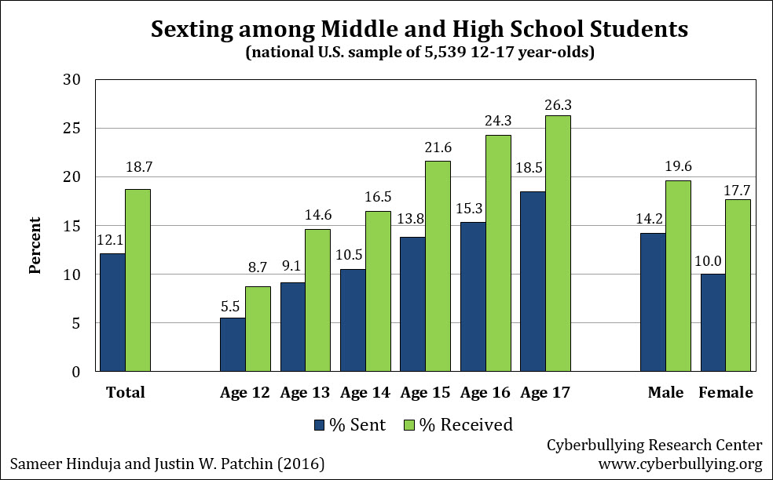
Despite the inconclusive results, this review shows that psychological aspects are related in some way to sexting, potentially as predictors of sexting behavior or as consequences, however, especially when taking into consideration sexting coercion or victimization. This finding is relevant because it can help raise awareness about the fact that sexting in adolescent populations should be further studied to establish effective mental health response programs and prevention programs, and that in some individual cases it might be a risky or dangerous behavior for teens to engage in or an indicator of some form of victimization. Along the same line, these findings suggest that both parents and educational communities should pay attention to both psychological symptoms and sexting behaviors since one can be a predictor of the other and vice versa.
Limitations: The limitations of this study are related to the use of a convenience sample that could not be considered as representative of the population. There could have being a social desirability effect due to the self-report questionnaire, even if they were anonymous. Moreover, this study was conducted only among college and personality traits that could be more related to sexting and dating violence. Finally, this research evaluated risky sexting behaviors taking into account the frequencies of behaviors. Future studies should further investigate risky dimensions of sexting focusing on different types of sexting and severity of the related consequences, i.e., studying the sharing of sexts of others without their consent or publicly posting one’s own photos.

References:
- Gaylord F.S. Sex, cells, and Sorna. William Mary Law Rev. 2011
- Gámez-Guadix M., de Santisteban P., Resett S. Sexting among Spanish adolescents: Prevalence and personality profiles. Psicothema. 2017
- Morelli M., Bianchi D., Baiocco R., Pezzuti L., Chirumbolo A. Sexting, psychological distress and dating violence among adolescents and young adults. Psicothema. 2016
- Temple J.R., Lu Y. Sexting from a Health Perspective: Sexting, Health, and Risky Sexual Behaviour. In: Walrave M., van Ouytsel J., Ponnet K., Temple J.R., editors. Sexting. 1st ed. Palgrave Macmillan; Chicago, IL, USA: 2018. pp. 53–61.
- Barrense-Dias, Y., Berchtold, A., Suris, J. C., & Akre, C. (2017). Sexting and the defi nition issue. Journal of Adolescent Health, 61(5), 544-554. https://doi.org/10.1016/j.jadohealth.2017.05.009

PLAGIARISM REPORT
